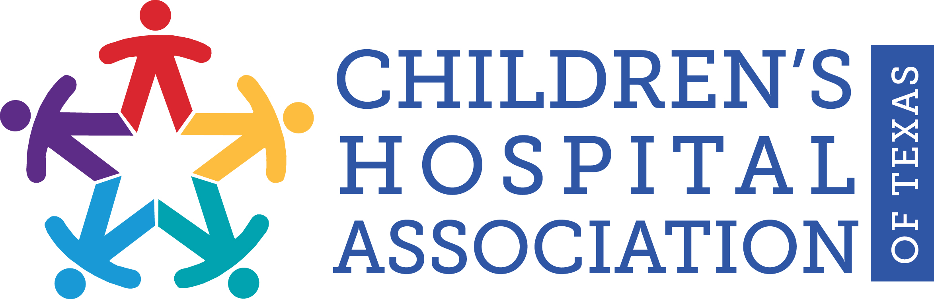
FOR IMMEDIATE RELEASE
March XX, 2017
Media Contact:
Heath Riddles and Lia Truitt
hriddles@echristianpr.com or ltruitt@echristianpr.com
512-472-9599

The Children’s Hospital Association of Texas Provides
Child Abuse Prevention Tips in Observance of
National Child Abuse Prevention Month

AUSTIN, Texas — Last year, according to Texas Child Protective Services, nearly 60,000 Texas children were abused or neglected. April is National Child Abuse Prevention Month, a time to acknowledge the importance of families and communities working together to prevent child abuse and neglect and to promote the social and emotional well-being of children and families.

Children of all backgrounds can be victims of abuse. It’s a problem that spans all ages, races, ethnicities, and socioeconomic backgrounds. Children ages 4–7 and 12–15 are most likely to be physically abused, but very young children are the most vulnerable to serious injuries as a result of child abuse.

If you do find yourself frustrated and angry at your child, please try the following to avoid hurting them:

- Take a deep breath and count to 20 slowly.
- Put your child in a safe place and WALK AWAY. The crib is usually a good choice for children who have not yet learned to climb out. For older children, walk out of the room but remain within hearing range to make sure that the child is safe.
- Now that your child is safe, take the time you need to calm down. This could just be a couple of minutes. If you need more time, reach out to a family member or friend to babysit for a while. Let them know how upset you are and that you need some help.
- Call for help! Never be afraid to call for help. Reach out to family, friends, your church, or a trusted adult. If you can’t get help and feel like you might hurt your child, call 911. They will help make sure you and your child are safe.
- Get rest. We are NOT at our best when we are over-tired and over-stressed. Just like airlines tell us, we must put on our oxygen first and then care for our child. Take care of yourself.

Child abuse prevention should be the shared responsibility of every community member. The Children’s Hospital Association of Texas (CHAT) offers the following advice to help prevent child abuse in our state.

“It’s not just parents who need to be vigilant,” Stacy Wilson, CHAT president, said. “By following a few simple guidelines, we can all help keep our children safer from potentially abusive situations. That makes for stronger, healthier communities.”
Here are 10 things you can do to help prevent child abuse:

- Know what child abuse is. In addition to physical and sexual abuse, neglect can also be an issue. Neglect includes the failure of parents or other caregivers to provide a child with needed food, clothing, and care. Children can also be emotionally abused when they are rejected, berated, or continuously isolated.
- Know how to recognize it. Unexplained injuries are just one sign of abuse. Habitual absence from school, depression, fear of a certain adult, difficulty trusting others or making friends, sudden changes in eating or sleeping patterns, inappropriate sexual behavior, poor hygiene, secrecy, and hostility can be signs that indicate a child is being neglected or abused.
- Educate yourself and others. After-school activities, parent education classes, mentoring programs, and respite care are all great ways to keep kids safe. Be a supportive voice for these efforts in your community.
- Volunteer your time. Get involved with community groups or other parents near you. Help vulnerable children and their families by starting a playgroup.
- Discipline your children thoughtfully. It’s never good to discipline a child in anger. Give yourself time to calm down, and remember that discipline is a way to teach your child. Use privileges to encourage good behavior and time-outs to help your child regain control. There is a substantial amount of literature that spanking, hitting, and other forms of physical punishment are not effective. Children disciplined in this way are more likely to be aggressive and have low self-esteem.
- Examine your behavior. Abuse can reach far beyond the physical. Words as well as actions can inflict deep, lasting wounds. Be a nurturer. Actions show children and other adults that conflicts can be settled in a healthy way, without hitting or yelling.
- Teach children their rights. When kids understand that they are special and have the right to be safe, they are less likely to think abuse is their fault. Then they become more likely to talk about potential abuse.
- Support prevention programs. Research options in your community that have been proven to stop abuse before it occurs—such as family counseling and home visits by nurses who provide assistance for newborns and their parents.
- Report abuse. If you see a child being harmed or witness evidence of abuse, call the local police or make a report to Texas Child Protective Services. If you’re talking to a child about suspected abuse, be sure to listen carefully, assuring the child that he or she did the right thing by telling an adult. Always affirm that he or she is not responsible for what happened.
- Invest in kids. Be an advocate by encouraging community leaders to support children and families. Ask employers to provide family-friendly work environments. Ask your local and national lawmakers to support legislation to protect our children and to improve their lives.

If you suspect that a child is being abused or neglected, please call the Texas Abuse Hotline at 1-800-252-5400. The Texas Department of Family and Protective Services (DFPS) recommends calling that number in at least the following situations:
- Serious injuries;
- Any injury to a child 5 years or younger;
- Immediate need for medical treatment (including suicidal thoughts);
- Sexual abuse where the abuser has or will have access to the victim within the next 24 hours;
- Children age 5 and under are alone or are likely to be left alone within the next 24 hours; and
- Anytime you believe your situation requires action in less than 24 hours.

If you would like more information on recognizing the signs of child abuse and neglect, visit the DFPS website. If you would like information on parenting classes available in Texas, visit “Find Help” section at www.HelpandHope.org or through the state’s Prevention and Early Intervention programs.

For more information about CHAT and its member hospitals, visit www.chatexas.com.

-30-

About the Children’s Hospital Association of Texas
The mission of the Children’s Hospital Association of Texas (CHAT) is to advance children’s health and well-being by advocating for policies and funding that promote children’s access to high-quality, comprehensive health care. Since 1989, CHAT has worked to advance its goals and public policy objectives in cooperation with other trade associations, advocacy groups, state agencies and the Texas Legislature.
www.chatexas.com

