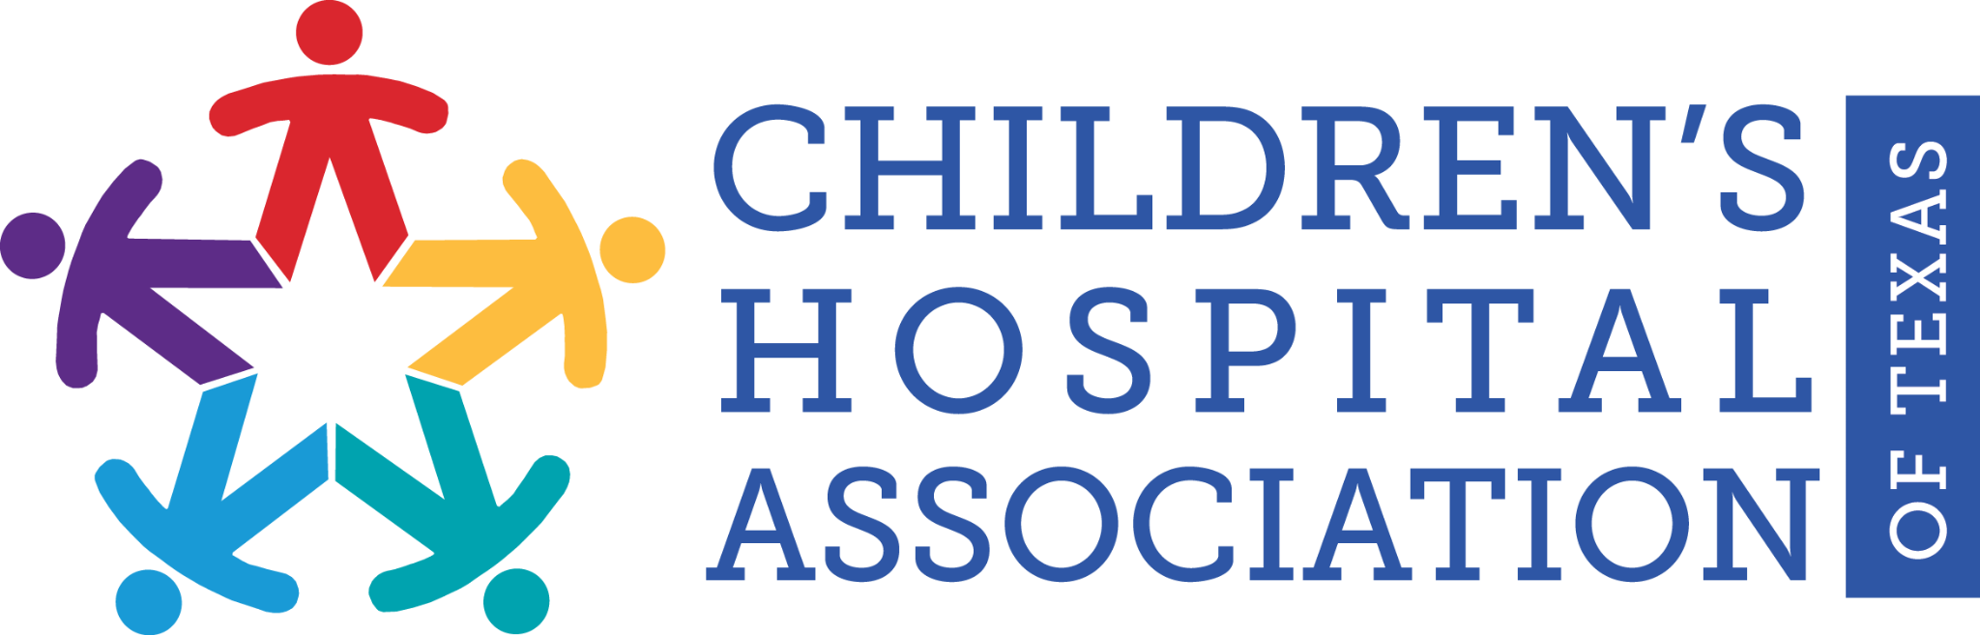

FOR IMMEDIATE RELEASE: December 20, 2021
Contact: Hilary Portay or Sarah Warnke
Elizabeth Christian Public Relations
hportay@echristianpr.com or swarnke@echristianpr.com
203.561.6095
214.773.5594

Children’s Hospital Association of Texas honors Representative Donna Howard with Children’s Health Care Hero Award

Austin, TX – Representative Donna Howard was honored by The Children’s Hospital Association of Texas (CHAT) with the Children’s Health Care Hero Award for her outstanding contributions and support of children’s healthcare initiatives during the 87th Legislative Session.

Rep. Howard is being recognized for her steadfast work to ensure that all Texans, particularly women and children, have access to quality healthcare. During the 87th Legislative Session, Rep. Howard championed children’s hospitals through her work on the House Appropriations Committee and filed House Bill 326 to help keep healthcare workers safe. Rep. Howard’s experience as a nurse and her tenure in the Texas Legislature are critical assets that enable her to lead on healthcare issues in a way that benefits children. The award was presented to Howard on December 17 at Dell Children’s Medical Center in Austin.

“CHAT is grateful to be able to work with Rep. Howard on issues facing children and their families. Supporting access to care for children and the pediatric workforce is even more important than ever as Texas continues to respond to the ongoing impacts of COVID-19. Her dedication to informed policymaking promotes the health and safety of all Texans.” Stacy Wilson, president of CHAT, said. “We are proud to honor Rep. Howard with this award for her leadership in the Texas Legislature to support access to quality healthcare for children, women, and families.”

The Children’s Health Care Hero Award recognizes Texas leaders who have demonstrated a commitment to an accessible, high-quality and appropriately funded children’s healthcare system in Texas.

"Texas is fortunate to have so many great children’s hospitals throughout our state, taking care of our most critically ill children. The Children’s Hospital Association of Texas is vital to ensuring our kids get the medical care they need while also advocating for keeping them healthy and safe. I’m honored to work with CHAT to support the health and well-being of our littlest Texans,” said Representative Donna Howard.

Prior to receiving the award, Rep. Howard toured Dell Children’s Medical Center. Dell Children’s Medical Center, part of Ascension, is the region’s only comprehensive children’s hospital and pediatric Level I trauma center.

"Dell Children's is proud to help recognize Representative Howard's leadership and dedication to all children and their families. She combines her experience and expertise as a critical care nurse, engaged civil leader, mother, and dedicated grandmother to raise awareness of issues affecting children and adolescents and help find solutions at the state legislature," said Christopher M. Born, president of Dell Children’s Medical Center.

Howard represents District 48 which covers much of central Austin.

###

About the Children’s Hospital Association of Texas
The Children’s Hospital Association of Texas (CHAT) is a non-profit association whose mission is to advance children’s health and well-being by advocating for policies and funding that promote children’s access to high-quality, comprehensive health care. Learn more about CHAT at chatexas.com or follow CHAT on Twitter at https://twitter.com/ChildHospAssnTX.

