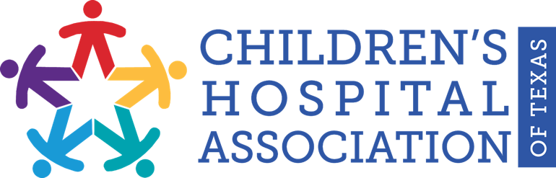

FOR IMMEDIATE RELEASE: April 21, 2021
Contact: Emma DeNard
Elizabeth Christian Public Relations
EDenard@echristinpr.com
713.829.8364

Children’s Hospital Association of Texas applauds
passage of key legislation for children’s health care
as part of the Healthy Families, Healthy Texas plan

Austin, TX – Children’s Hospital Association of Texas (CHAT) applauds the passing of three bills that will further support children’s health and well-being as it relates to telehealth and telemedicine, coverage for children on Medicaid, and maternal health.

Speaker Dade Phelan and a coalition of Texas House of Representative members have proposed a bipartisan healthcare plan titled, Healthy Families, Healthy Texas. The plan includes legislation that will greatly increase access to care for many patients, particularly children. House Bill 4, authored by Representative Four Price (R-Amarillo), provides greater access to care through telehealth and telemedicine and ensures Medicaid providers can continue to provide these innovative services. House Bill 290, authored by Representative Philip Cortez (D-San Antonio), streamlines the Medicaid eligibility process for children and helps keep eligible children on coverage. House Bill 133, authored by Representative Toni Rose (D-Dallas), extends coverage for new moms so they receive 12 months of Medicaid postpartum.

“The Children’s Hospital Association of Texas is thrilled to see that the Texas House has passed critical legislation ensuring children have access to the highest quality health care through pediatric telehealth and telemedicine, eligible children remain enrolled in Medicaid, and new moms have access to 12 months of postpartum care” Stacy Wilson, president of CHAT, said. “Texas kids and their families deserve the best when it comes to health care, and families across the state will be greatly impacted by these bills. We thank Speaker Phelan for his leadership on this incredible effort and success that will improve health outcomes for all Texans, especially our most vulnerable citizens—our children.”

HB 4, HB 133 and H 290 passed in the Texas House of Representatives with bipartisan support on Thursday, April 15.

###

About the Children’s Hospital Association of Texas
The Children’s Hospital Association of Texas (CHAT) is a non-profit association whose mission is to advance children’ health and well-being by advocating for policies and funding that promote children’s access to high-quality, comprehensive health care. Learn more about CHAT at chatexas.com or follow CHAT on Twitter at https://twitter.com/ChildHospAssnTX.

