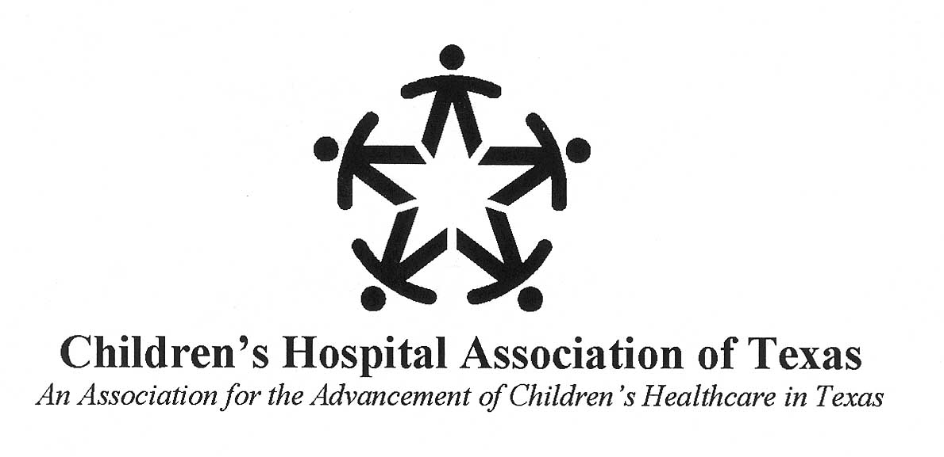

FOR IMMEDIATE RELEASE: May 12, 2016
Contact: Lia Truitt or Heath Riddles
512-472-9599
ltruitt@echristianpr.com or hriddles@echristianpr.com

Children’s Hospital Association of Texas Names New President, Stacy E. Wilson
The Children’s Hospital Association of Texas (CHAT) announced today that Stacy E. Wilson, current vice president and associate general counsel for the Texas Hospital Association (THA), has been selected as CHAT’s new president. CHAT is a non-profit association with seven children’s hospital members, including Children’s Health System of Texas, Children’s Hospital of San Antonio, Cook Children’s Health Care System, Covenant Children’s Hospital, Dell Children’s Medical Center of Central Texas, Driscoll Children’s Hospital and Texas Children’s Hospital. CHAT’s mission is to ensure that Texas children have access to effective, high quality, comprehensive and appropriately funded health care.

“I am honored and humbled to have been selected as CHAT’s next president,” Wilson said. “It is a privilege to be part of an organization that supports the critical mission of its hospital members. Not only are our members delivering high-quality health care to Texas children every day, but they are also addressing the social determinants of health to ensure that they are giving children the best start in life that they can have, and I’m excited to be part of their story.”

Wilson succeeds Bryan Sperry, CHAT’s first and only president since 1994. Sperry served 16 years in Texas state government and is retiring in 2016.

“The CHAT Board engaged in a robust search for someone to take the reins from Bryan, who has done a superb job in advocating for children’s hospitals during his long tenure,” Mark Shen, MD, board chair of CHAT and president of Dell Children's Medical Center, said. “We believe that Stacy has the experience, zeal and expertise to build on Bryan’s great work to take children’s hospitals further in their journey to be looked to as the health care delivery model.”

Prior to her role as vice president and associate general counsel for THA, Wilson served as director of Government Affairs for Central Health and CommUnityCare, as well as general counsel for Central Health. She has twenty years of experience in health policy, advocacy and health law. Wilson completed undergraduate at The University of Texas at Austin and law school at Texas Tech University School of Law.

###

About the Children’s Hospital Association of Texas
The mission of the Children’s Hospital Association of Texas (CHAT) is to support the development of an effective, comprehensive, high-quality and appropriately funded children’s healthcare delivery system in Texas. Since 1989, CHAT has worked to advance its goals and public policy objectives in cooperation with other trade associations, advocacy groups, state agencies and the Texas Legislature. www.childhealthtx.org

