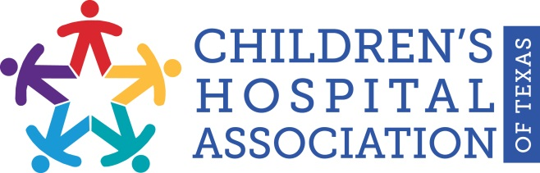
FOR IMMEDIATE RELEASE
January 18, 2017
Media Contact:
Heath Riddles and Lia Truitt
hriddles@echristianpr.com or ltruitt@echristianpr.com
512-472-9599

Children’s Hospital Association of Texas (CHAT)
Welcomes El Paso Children’s Hospital as New Member

CHAT to Advocate at 85th Legislature on Behalf of Eight Member Hospitals

AUSTIN, Texas — The Children’s Hospital Association of Texas (CHAT) announced today that El Paso Children’s Hospital has re-joined the nonprofit association, which represents and advocates for eight of Texas’ largest and most utilized nonprofit children’s hospitals, after a two-year hiatus.

“We are thrilled to welcome back El Paso Children’s Hospital to CHAT,” Stacy Wilson, president of CHAT, said. “It is important we serve children from all over Texas. There are a million residents in El Paso and not another not-for-profit children’s hospital in a 200-mile radius, so we are pleased to be able to represent this important area of the state.”

CHAT’s mission is to advance children’s health and well-being by advocating for policies and funding that promote children’s access to high-quality, comprehensive health care. In addition to El Paso Children’s Hospital, CHAT’s member hospitals include: Children’s Health (Dallas), the Children’s Hospital of San Antonio, Cook Children’s Health Care System (Fort Worth), Covenant Children’s Hospital (Lubbock), Dell Children’s Medical Center of Central Texas (Austin), Driscoll Children’s Hospital (Corpus Christi) and Texas Children’s Hospital (Houston).

“It is important for El Paso Children’s Hospital to join CHAT to not only better serve children in our area, but to also work with the other CHAT member hospitals to advance the safety and quality of medical treatment provided at all of the eight member hospitals,” Mark Amox, chief executive officer, El Paso Children’s Hospital, said. “Not only do we serve children in more than 16 surrounding counties, but along with Covenant Children’s Hospital in Lubbock, we serve approximately half of the children in New Mexico.”

During the 85th Legislature, CHAT plans to focus primarily on increasing Medicaid outpatient rates, improving the medical care provided to children in the foster care system, and maintaining the safety-net add-on for Medicaid hospitals. Additionally, CHAT and its member hospitals continually work on the CHAT Quality Collaborative, which was created to improve the quality and safety of care for the most common childhood diseases by identifying and standardizing best practices for treatment.

“El Paso Children’s Hospital joins CHAT during a key time with a strong commitment to quality and safety. The hospital is participating in a national sepsis collaborative that will provide useful information for CHAT’s sepsis collaborative,” Wilson said. “Also, El Paso Children’s Hospital, along with CHAT member Driscoll Children’s Hospital in Corpus Christi, provides knowledge and experience on border issues that are important to the state.”

El Paso Children’s Hospital opened in 2012 as the only not-for-profit children’s hospital in the region and the largest in West Texas. El Paso Children’s Hospital features 122 private pediatric rooms, state-of-the-art equipment, family friendly space, kids “pain-free” playrooms, pediatric rehabilitation, pediatric emergency department, pediatric imaging, pediatric inpatient and outpatient infusion, pediatric intensive care unit, pediatric operating rooms, pediatric critical care transport team, and a Level III neonatal intensive care unit. El Paso Children’s Hospital has recruited more than 30 pediatric subspecialists and is actively recruiting more pediatric subspecialists.

The mission of El Paso Children’s Hospital is to provide compassionate, coordinated, family-centered care for children with a dedicated commitment to excellent patient outcomes, inclusive leadership and innovative pediatric research and education.

For more information about CHAT and its member hospitals, visit www.chatexas.com.

For more information about El Paso Children’s Hospital, visit elpasochildrens.org

-30-

About the Children’s Hospital Association of Texas
The mission of the Children’s Hospital Association of Texas (CHAT) is to advance children’s health and well-being by advocating for policies and funding that promote children’s access to high-quality, comprehensive health care. Since 1989, CHAT has worked to advance its goals and public policy objectives in cooperation with other trade associations, advocacy groups, state agencies and the Texas Legislature.
www.chatexas.com

